Data Standards to Combat Loneliness
Purpose of report

To present an opportunity to participate in a cross-government initiative to develop strategies to help combat loneliness, making use of local government expertise in the area of local services data and data standards.

Summary

A programme of work in the data and transparency area for 2018-19 was presented to and approved by the board in March 2018. One of the approved work packages was to pilot a new data standard for local services. Early applications are thought to be particularly useful for helping vulnerable people.

Our expertise has come to the attention of the Cabinet Office, DCMS and the Prime Minister’s Office, who are keen to trial pilot solutions as part of a cross- government initiative to tackle loneliness. This paper summarises the problem and proposes a programme overseen by the LGA to support the work. It is likely that the bulk of activity will take place in 2019-20.

Recommendation
That the board considers and approves in principle this opportunity.

Action
The work would be conducted as part of the data and transparency programme, for which Mayor Dave Hodgson is the lead member, and would be delivered by members of the Research and Information Team and selected external partners.

Lead Member: Mayor Dave Hodgson MBE
Contact officer: Dr Tim Adams / Juliet Whitworth

Position: Programme Manager / Research & Information Manager

Phone no: 07789 937675 / 020 76643287

Email: tim.adams@local.gov.uk / juliet.whitworth@local.gov.uk

Data Standards to Combat Loneliness

Background

- For several years, the LGA has delivered programmes of work to help authorities get a better understanding of the data that they hold, along with the development of local government information standards (to aid the tagging, structuring, linking and comparison of data), guidance and online support. The objective has been to meet the expectations of the transparency agenda and to realise efficiencies through better use of data.

- Last year we worked with a number of councils in the north west to develop a new data standard for publishing information about local services (for example, a format for telling people the name of a service, what day it is on, what time it is on etc). This can be used by all local partners in an area, to publish service information in the same format, which means that information about all their services can be gathered and published together.

- In March, the Improvement and Innovation Board agreed that in the coming financial year one of the work areas for the data and transparency programme would be a pilot of this new local service standard: it would entail the LGA working with a few local authorities and their partners, to publish data openly about their services; and then the commission of a small number of example apps that can discover and present that data. This would demonstrate the power of what can be achieved if everyone in the area publishes their information in the same way.

Prime Minister’s Announcement on Loneliness

- In early 2018, the Prime Minister announced a cross-government initiative to work to combat loneliness. Funding and central government resources have been made available for this work, which is being coordinated by the Cabinet Office and DCMS.

- The LGA has been approached to participate in this initiative, because of our experience in developing the local government information standards, and particularly because of our work on the new local service standard. We have been able to demonstrate to DCMS and Cabinet Office how data published to this new standard would allow users to identify local services and match, filter and apply them to the challenges of loneliness.

- Working with a number of partners in the private and local government sector, we have now presented a costed proposal to DCMS and the Cabinet Office, to build on our existing local service standard and deliver a number of local authority (and partner) pilots focussing on loneliness, as well as commission an app that can publish the data, and to capture any learning. The proposal has been undergoing scrutiny and revision for the past two months.

- It is looking increasingly likely that a grant of around £150,000 would be made available to us to progress this project, along with Cabinet Office support and promotional help, providing that the LGA is able to lend its skills, outreach and knowhow towards successful implementation. Since the Improvement and Innovation Board already approved further work on the local service standard for this year, which would cover our internal contribution to this work, and the funding of LGA staff costs would come from MHCLG grant. The £150,000 would instead buy in capacity and expertise, and additional resource to allow us to capture lessons.

- Whilst not yet confirmed, if the Improvement and Innovation Board agrees we should pursue this project and Cabinet Office/DCMS agree to fund us, it would be most likely to begin in 2019-20, although some of the planning and preparation may start in 2018-19. Subject to all parties’ agreement, the Cabinet Office would make an announcement of this work sometime in October (probably within a speech by the Prime Minister).

The challenge
- The range and diversity of local public and community services is vast. They are commissioned and delivered by many different organisations. Different people need different combinations of services and different channels of delivery. To understand the landscape of what services are available, to whom they are directed and how to apply to use them would usually involve time-consuming research.

The challenge to finding and matching the right local services for a lonely person to meet their needs may be summarised as follows.

9.1 Local services are delivered by a wide range of different types of local authorities and by delivery partners drawn from community groups, the voluntary sector, and the private sector.

9.2 Citizens or their advocates, clinicians, GPs, carers and families rarely understand the complex structures of local service delivery and often do not know of their existence.

9.3 Lonely people often present themselves to the health sector and GPs who realise that their problems are non-clinical but have no easy recourse to direct them to other appropriate services.

9.4 Throughout the country there are different levels, volumes and qualities of local services in different areas, but we have no easy way of quantifying and balancing these issues.

9.5 The traditional boundaries of local government are not relevant when trying to identify appropriate services for individuals: rather, they should be based upon their location, locality, eligibility and circumstances.

- This project suggests a strategy to resolve many of these issues. It builds upon the large investments made in local government over a decade to manage service information to common standards and it deploys modern IT and data processing techniques to publish information about local services in a consistent way. As a result, tools can be developed to identify appropriate services that best meet the personal needs and circumstances of a lonely individual (for example, a GP could find details of a cookery class run by a local voluntary organisation, or a reminiscence session in the local library, for a patient in front of them by going to a single tool).

The proposed approach

- In brief, we propose to identify up to four pilot areas with a lead local authority and a selection of local partners to catalogue local services helpful to lonely people. This data will be quality assured, and then published to the new local service data standard that the LGA developed with partners last year.

- The preparation and publication of the service data is time-consuming, but we will make available tools and guidance material to help the authority and local partners. Once the data is published, we envisage that data and application developers will create websites and tailored apps to discover these services and to filter them to address the individual needs of citizens being served. We will, however, commission a one or two example apps to ensure the pilot areas have a way to display their data.
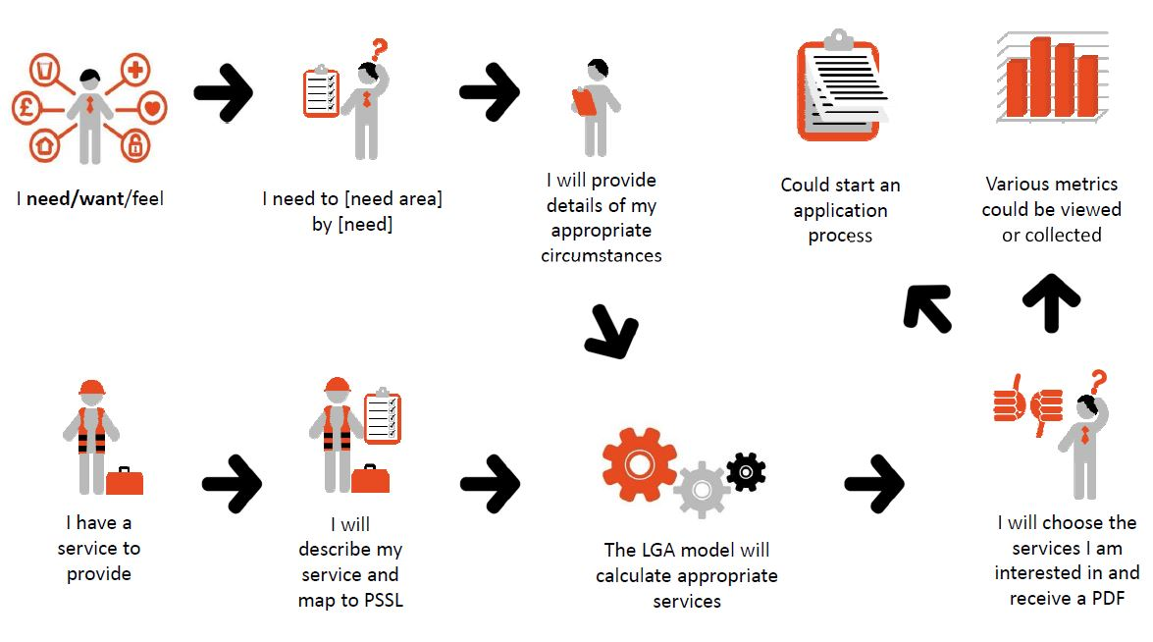
Chart 1: Proposed flowline from the data consumer and data publisher viewpoint

Benefits realisation
- There are a number of potential benefits to developing the local service standard for loneliness, particularly if it is taken up widely by local service delivery organisations, including:

13.1 It simplifies local service access by removing the need to understand which organisations deliver which services.

13.2 It helps improve people’s lives by providing frontline workers with a way to identify appropriate services by suggesting those that best meet the needs and circumstances of their clients. In the longer term, there is potential to extend the discovery tools to go further and invoke applications for service.

13.3 It helps improve people’s lives by providing quality data that people can self-serve, so helping to reduce signposting demand on the frontline and it removes unnecessary contact with organisations. There is less ‘pillar to post’ passing.

13.4 In the longer term it will reduce costs for organisations publishing information about their services, by collecting and maintaining data once, but allowing it to be used many times.

13.5 It will improve data quality and reliability by focusing resources into better assurance.

13.6 It gives the potential to identify and catalogue local services on a national basis.

13.7 It will likely stimulate the app development market since data will emerge on a national basis to the same open standard. There may be potential for service providers to generate income from making data available to commercial apps.

Risks

- As this proposal is seen as a learning exercise, there is acceptance that we are not wholly sure of the outcomes and its success. Nonetheless, from earlier work in this area, we hope that substantial progress and learning can be achieved in taking part. There are a small number of risks worthy of recording:

We may not be able to persuade four pilot areas and partners to participate, though we have made tentative approaches with positive reception.

Cabinet Office and DCMS are placing importance on us working with other groups who claim to have expertise in this area. Examples include: Government Digital Service and the Open Data Institute. From earlier experience, these groups pay little attention to the special challenges of local government and there could be pressure to compromise our approach.

Financial Implications

- If Cabinet Office progresses this project, they have indicated a budget of around £150,000 would be made available to us to buy in external capacity and expertise, some support for authorities taking part and to conduct an exercise to capture lessons. The LGA’s staff costs would be covered by MHCLG grant, which has already been identified for this financial year.

Implications for Wales

- At present, it is not anticipated that any of the pilot authorities will be Welsh. However, the outputs and learning from this project will apply to authorities in Wales, and will be promoted to them as well as English, Scottish and Norther Irish authorities.

Next Steps

- The board is asked to consider and approve in principle this opportunity. Although the local service data standard can be used for any local service, the focus on loneliness means the standard can be tested out on a topic that is high on the political agenda, at both national and local level, and with positive benefits for individuals.

